|  |
| --- |
|  |
| 新概念 3 册 |
| Lesson55 |

Lesson 55 From the earth: Greetings

**astronomy [ə'strɒnəmi]**

**n. 天文学**

“astr” / “aster” = star

astronomy astronomical

astrology astronautics

astronaut disaster

asterisk asteroid

“stell” = star

stellar stellar light stellar system interstellar interstellar travel

constellation a constellation of famous scientists and artists

solar ['səʊlə(r)] adj. 太阳的

solar energy solar system

solar radiation solar calendar a partial / total solar eclipse

lunar

lunar calendar

a partial / total lunar eclipse

Venus ['vi:nəs]

**n. 金星**

Mercury（水星，商贸之神墨丘利） Venus（金星，美神维纳斯） Mars（火星，战神马尔斯） Jupiter（木星，众神之王朱庇特） Saturn（土星，农神萨图恩）

Uranus（天王星，天空之神乌拉诺斯） Neptune（海王星，海神尼普顿） Pluto（冥王星，冥王普路托） **bacteria [bæk'tɪəriə]**

n. 细菌

bacterium ➔ bacteria datum ➔ data medium ➔ media stratum ➔ strata curriculum ➔ curricula **realm [relm]**

n. 王国；范围，领域

the realm of literature / science the political / military realm the realm of necessity

the realm of freedom

The history of mankind is one of continuous development from the realm of necessity to the realm of freedom.

domain

the political domain

the domain of natural science field / area / world / sphere the field of politics

the world of art

the area of education the diplomatic sphere the ideological sphere

Recent developments *in astronomy* have made it possible to detect planets in our own Milky Way and in other galaxies.

detect v. to discover or notice sth, especially sth that is not easy to see, hear, etc. 发现，觉察

The tests are designed to detect the disease early.

an instrument that can detect small amounts of radiation the Milky Way = the Galaxy 银河

in relative terms: compared with other, similar things 相对来说Students have less money in relative terms, but spend more on books. prove (to be) + adj. / n. 被证明是……

The search proved difficult, for the puma was often observed at one place in the morning and at another place 20 miles away in the evening.

infinitely adv. very much ― used esp. when comparing things （尤其与比较级连用）……得多

Your English is infinitely better than my German.

Travel is infinitely more comfortable now than it used to be. far / much / even / still / yet + 比较级

support v. to provide the right conditions, such as enough food and water, for life （提供合适的条件以）维持生命，使活下去

The land is so poor here that it cannot support any crops. Because of pollution, this lake is now too acid to support fish.

Only the Earth provides ideal conditions, and even here *it* has taken more than 4 billion years for plant and animal life *to evolve*.

it takes … (for …) to do sth.

It took a few minutes for his eyes to adjust to the dark.

It can take as long as eight days to rig up rope ladders and to establish supply bases before a descent can be made into a very deep cave.

Whether a planet can support life depends on the size and brightness of its star, that is its 'sun'. that is (to say): or more exactly 也就是说，确切地说

The fare is reduced for children, that is anyone under 15 years old.

One solution would be to change the shape of the screen, that is, to make it wider. Languages are taught by the direct method, that is to say, without using the student's own language.

I loved him ― that is, I thought I did.

I'll meet you in the city, that is, I will if the trains are running.

One authority on spiders made a census of the spiders in a grass field in the south of England, and he estimated that there were more than 2,250,000 in one acre, that is something like 6,000,000 spiders of different kinds on a football pitch.

The film is only open to adults, i.e. people over 18.

The hotel is closed during low season, i.e. from October to March. The price must be more realistic, i.e. lower.

She has worked at the bank for many years, nine to be exact.

He was economical with the truth ― in other words, he was lying. It's fairly risky. Or to put it another way, don't try this at home.

Imagine a star up to 20 times larger, brighter and hotter than our own sun. Imagine life without hot water.

Imagine that you have just won a million pounds.

Imagine their dismay when they found a beautifully-cooked wallet and notes turned to ash! up to sth.: 1. as much or as many as a certain amount or number but not more 多 达 …… The Olympic Stadium will hold up to 80,000 spectators.

The temperature went up to 35℃. up to sth.: 2. = up till

for the whole of a period until a certain time or date 直到……

Up to the time of his death, Richard Colson was one of the most notable figures in our town.

Up to now, historians have assumed that calendars came into being with the advent of agriculture, for then man was faced with a real need to understand something about the seasons. Alternatively, if the star *were* small, the life-supporting planet *would* have to have a close orbit *round it* and also provide the perfect conditions *for life forms to develop*.

alternatively adv. used to introduce a suggestion or to mention sth. different to what has just been stated 或者

The agency will make travel arrangements for you. Alternatively, you can organize your own transport.

We could go to the Indian restaurant, or alternatively, we could try that new Italian place. the planet which supports life

➔ the life-supporting planet animals which eat insects

➔ insect-eating animals silverware which is made by hands

➔ hand-made silverware

diseases which are related to stress

➔ stress-related diseases state-owned enterprises flower-selling girls

epoch-making masterpieces cancer-causing substances

Alternatively, if the star were small, the life-supporting planet would have to have a close orbit round it and (would) also (have to) provide the perfect conditions for life forms to develop.

He opened a door and stood aside for *her* to pass.

Her circumstances had never been good enough for *her hopes* to be realized. But how *would* we find such a planet if there *were* such a planet?

At present, there is no telescope *in existence* that is capable of detecting the presence of life. in existence 存在

The organization has been in existence for 25 years. come into existence 开始存在

Scientists have many theories about how the universe first came into existence. presence n. the existence of sb. or sth. in a particular place 存在

one’s presence

Her presence during the crisis had a calming effect.

We enjoy staring at them entranced as they go about their business, unaware (we hope) of our presence.

the presence of …

Tests revealed the presence of poison in the blood.

The presence of pollen in the atmosphere causes hay fever in some people. detect the presence of … 寻找……

a device for detecting the presence of submarines

The dogs were trained to detect the presence of explosives.

develop v. to design or make a new idea, product, system etc. over a period of time 开发，研制

Scientists are developing new drugs to treat arthritis.

development n. the process of creating a new product or method 开发，研制

His work is mainly in software development.

The funds will be used for product development.

The resolution of some problems of today is urgent and critical for the survival of a society. Overemphasis upon some existing problems could cause harmful effects.

The efforts to solve problems of the future is sometimes of paramount importance for the avoidance of potential threats or even catastrophes we can anticipate.

His acceptance of bribes led to his arrest. My arrival coincided with his departure.

It is impossible to look for life on another planet using earth-based telescopes.

-based: 1. combines with nouns referring to places to mean sth. positioned or existing mainly in

the place mentioned, or operating or organized from that place 位于…… a Washington-based organization

land-based missiles

-based: 2. used with some names to make adjectives describing the main substance in a product

主要成分为…… lead-based paints carbon-based fuels

nitrogen-based fertilizer

pasta and other wheat-based products

Our own warm atmosphere and the heat generated by the telescope *would* make it impossible *to detect objects as small as planets*.

Our own warm atmosphere and the heat generated by the telescope *would* make it impossible to detect objects as small as planets if we *looked* for life on another planet using earth-based telescopes.

Even a telescope *in orbit round the earth*, like the very successful Hubble telescope, *would* not be suitable *because of the dust particles in our solar system*.

Even a telescope in orbit round the earth, like the very successful Hubble telescope, *would* not be suitable because of the dust particles in our solar system if we *looked* for life using a telescope in orbit round the earth.

Hubble Edwin Powell 1889-1953. American astronomer who discovered (1929) that the velocities of nebulae increase with distance

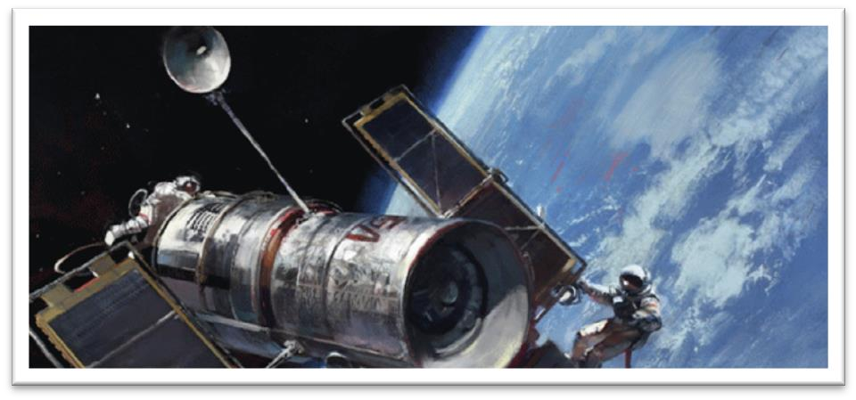Hubble Space Telescope (HST)

The Hubble Space Telescope is a telescope in orbit around the Earth.

Its position outside the Earth's atmosphere allows it to take extremely sharp images, and since its launch in 1990, it has become one of the most important telescopes in the history of astronomy. It has been responsible for many ground-breaking observations and has helped astronomers achieve a better understanding of many fundamental problems in astrophysics.

particle n. a very small piece of sth. 微粒

dust particles

tiny particles of soil

elementary particle n. one of the types of pieces of matter including electrons, protons, and neutrons that make up atoms 基本粒子

A telescope *would* have to be as far away as the planet Jupiter *to look for life in outer space*, because the dust becomes thinner *the further we travel towards the outer edges of our own solar system*.

A telescope *would* have to be as far away as the planet Jupiter to look for life in outer space if we *looked* for life in outer space, because the dust becomes thinner the further we travel towards the outer edges of our own solar system.

The harder they worked the hungrier they became. They became (the) hungrier the harder they worked.

We are so familiar with the fact that man ages, that people have for years assumed that the process of losing vigour with time, of becoming more likely to die the older we get, was something self-evident, like the cooling of a hot kettle or the wearing-out of a pair of shoes. Once we *detected* a planet, we *would* have to find a way *of blotting out the light from its star*, so that we *would* be able to 'see' the planet properly and analyze its atmosphere.

way of doing sth.

a new way of storing information way to do sth.

What is the best way to clean this?

blot n. a mark or dirty spot on sth., esp. made by ink 污点，墨迹

ink blots

This is a serious blot on your career.

blot out: to cover sth. so that you can no longer see it 遮住

Dark clouds overhead had blotted out the sun.

so (that) 作连词时一般来说有两种用法：1. 引导结果状语从句，译为“所以”，从句谓语动词中一般没有情态动词。

2. 引导目的状语从句，译为“以便”= in order that …，从句谓语动词中多出现情态动词 can, could, may, might, should, would 等。

We paid him immediately, so (that) he left contented.

We paid him immediately, so (that) he would leave contented. properly adv. (BrE) completely, fully, thoroughly 完全地，彻底地Is the chicken properly defrosted?

He got properly beaten by the world champion.

If we *looked* for life on a planet, in the first instance, we *would* be looking for plant life, rather than 'little green men'.

in the first instance (fml.) as the first part of a series of actions 首先，第一

In the first instance, notify the police and then contact your insurance company. Anyone wishing to join the society should apply in the first instance to the secretary. Little green men is a popular expression used to describe extraterrestrial life.

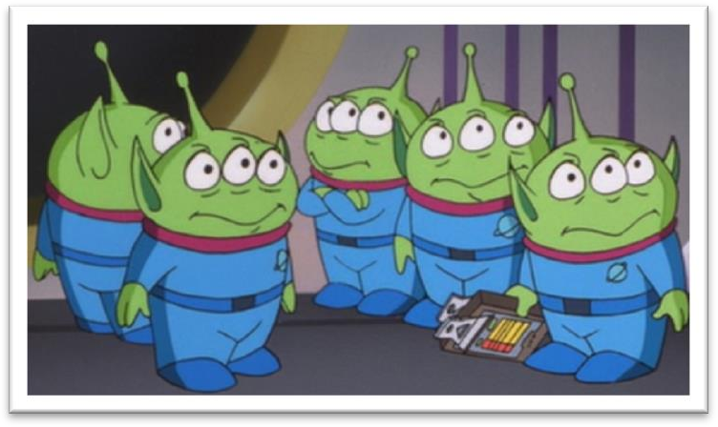

The life forms most likely to develop on a planet *would* be bacteria.

The life forms most likely to develop on a planet *would* be bacteria if the planet *could* support life.

It is bacteria that have generated the oxygen *we breathe on earth*.

As Earth-dwellers, we always cherish the hope *that we will be visited by little green men* and *that we will be able to communicate with them*.

The city dweller never experiences anxieties of this sort.

cherish v. to keep hopes, memories or ideas in your mind because they are important to you and bring you pleasure 长期怀有某种感情

Like a scientist bent on making a discovery, he must cherish the hope that one day he will be amply rewarded.

He cherished the hope of winning an Olympic medal. He cherished the memory of his late wife.

He cherished the illusion that the girl was in love with him. an idea that belongs in the realm(s) of science fiction

I suppose it's not beyond the realm(s) of possibility. This is not really within the realm(s) of my experience.

science fiction (also informal sci-fi) n. [U] a type of book, film/movie, etc. that is based on imagined scientific discoveries of the future, and often deals with space travel and life on other planets 科学幻想（科幻）

If we *were* able to discover lowly forms of life like bacteria on another planet, it *would* completely change our view of ourselves.

lowly adj. low in rank, importance, or social class 卑微的，低等的

He was a lowly assistant gardener. low adj. & adv. 低的（地）

bow low to the Queen That plane's flying too low!

We were, however, worried about our nearest neighbours, whose farm was low lying and who were newcomers to the district.

As Daniel Goldin of NASA observed, 'Finding life elsewhere *would* change everything. No human endeavour or thought *would* be unchanged by it.'

Daniel Goldin

Daniel Saul Goldin (born July 23, 1940) served as the 9th and longest-tenured Administrator of NASA from April 1, 1992, to November 17, 2001. He was appointed by President George H. W. Bush and served under three presidential administrations.

NASA n.

National Aeronautics and Space Administration a US government organization that controls space travel and the scientific study of space （美国）国家航空航天局

observe v. (fml.) to make a written or spoken comment about someone or something （评论）说

"I've always found German cars very reliable," he observed. She observed that it would soon be time to stop for lunch.

observation n. a spoken or written remark about something you have noticed 言论，评论

A young English writer made the pertinent observation a year or two back that the talent goes into the first draft, and the art into the drafts that follow.

elsewhere adv. in, at, or to another place 在别处，到别处

The answer to the problem must be sought elsewhere.

Our favourite restaurant was full, so we had to go elsewhere.

Finding life elsewhere *would* change everything if life *were* found elsewhere.

If life *were* found elsewhere, no human endeavour or thought *would* be unchanged by it.